**Project Design Phase-II**

**Data Flow Diagram & User Stories**

|  |  |
| --- | --- |
| Date | 27 June 2025 |
| Team ID | LTVIP2025TMID59978 |
| Project Name | SmartSDLC – AI-Enhanced Software Development Lifecycle |
| Maximum Marks | 4 Marks |

**Data Flow Diagrams:**

The Data Flow Diagram (DFD) for the SmartSDLC – AI-Enhanced Software Development Lifecycle project illustrates how data moves across various components of the system. At its core, the system begins with user interactions such as registration and task input through a web interface or voice input. These inputs are processed by AI modules—such as a requirement analyzer, code assistant, and task generator—which utilize services like IBM Watson STT and AI models for automation. The processed data flows into storage systems like IBM Cloudant and GitHub repositories, while project status, analytics, and code suggestions are presented back to users through a unified dashboard. External APIs like Jira and GitHub support real-time syncing and version control. The DFD clearly visualizes how SmartSDLC integrates AI to enhance software development workflows, from planning and coding to deployment and monitoring.

**Example:** [**(Simplified)**](https://developer.ibm.com/patterns/visualize-unstructured-text/)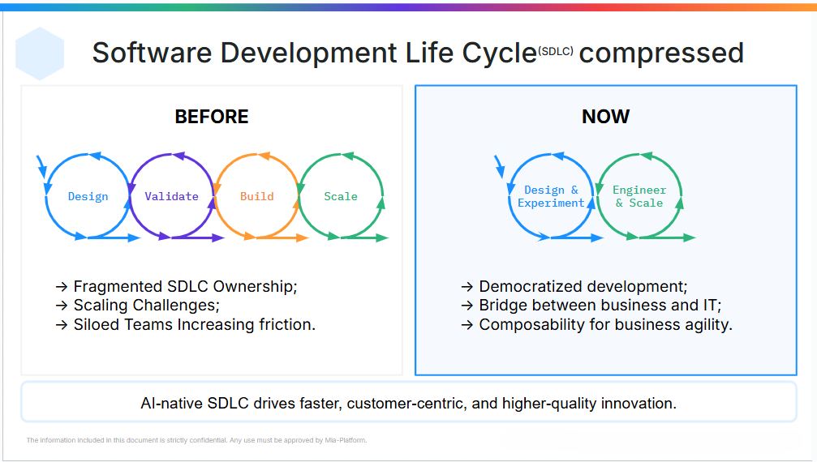

**User Stories**

Use the below template to list all the user stories for the product.

|  |  |  |  |  |  |  |
| --- | --- | --- | --- | --- | --- | --- |
| **User Type** | **Functional Requirement (Epic)** | **User Story Number** | **User Story / Task** | **Acceptance criteria** | **Priority** | **Release** |
| Customer (Mobile user) | Registration | USN-1 | As a user, I can register for the application by entering my email, password, and confirming my password. | I can access my account / dashboard | High | Sprint-1 |
|  |  | USN-2 | As a user, I will receive a confirmation email once I have registered for the application. | I can receive confirmation email & click confirm | High | Sprint-1 |
|  |  | USN-3 | As a user, I can register for the application through Facebook. | I can register & access the dashboard with Facebook Login | Low | Sprint-2 |
|  |  | USN-4 | As a user, I can register for the application through Gmail. | I can register & access the dashboard using Gmail login | Medium | Sprint-1 |
|  | Login | USN-5 | As a user, I can log into the application by entering email & password. | I am redirected to the dashboard after successful login | High | Sprint-1 |
|  | Dashboard | USN-6 | As a user, I can view my current tasks and project progress on a dashboard. | Dashboard shows task list, status updates, and recommendations | High | Sprint-2 |
| Customer (Web user) | Task Management | USN-7 | As a user, I can create, edit, and delete development tasks. | Tasks reflect correctly in project tracker | High | Sprint-2 |
| Customer Care Executive | Support Ticket Management | USN-8 | As a support executive, I can view and respond to user queries and tickets. | I can respond and mark tickets as resolved | Medium | Sprint-3 |
| Administrator | User & Role Management | USN-9 | As an admin, I can add, edit, and remove users and assign roles. | User roles are correctly applied and updated in the system | High | Sprint-1 |
|  | System Monitoring | USN-10 | As an admin, I can monitor AI module performance and service health. | System shows uptime and error logs for AI services | High | Sprint-3 |
|  | Integration with GitHub & Jira | USN-11 | As an admin, I can configure and manage integrations with GitHub and Jira. | Sync with GitHub and Jira is functional and logs changes | Medium | Sprint-3 |
|  | AI Code Assistance | USN-12 | As a user, I can receive AI-generated code suggestions for selected tasks. | AI provides relevant suggestions within the IDE or dashboard | High | Sprint-3 |